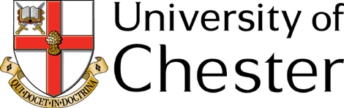

PERSONAL STATEMENT

BA WORKING WITH CHILDREN, YOUNG PEOPLE & FAMILIES (WBIS)

Section A – Your details
Name

Address

Post Code
Intended start date (Month & Year) | Mode of Study (Full or Part Time)

Section B – Personal Statement
(Please write a statement to support your application to study on this course – include reference to how your qualifications, experience and interests have led you to want to apply, and ideas that you might have for future career development during/after the end of the course. Use the course description and module outlines from the course web page to help you relate what you have done and know already to how you might be able to develop yourself during the course. Remember to include reference to both your experience and knowledge of working with children/young people, as well as other employment and training you have done.)

Once you have completed this form, as well as an Application Form:
Email your completed and signed documents to admissions@chester.ac.uk.
If you have any admissions queries, please contact admissions@chester.ac.uk.

Please refer to the Application Guidance Notes for further information. If you have any queries regarding this course please contact wbisenquiries@ucshrewsbury.ac.uk.

